REMOVE BST

The Following BST is built by entering the following numbers:

50 25 75 12 33 67 88 6 13 68

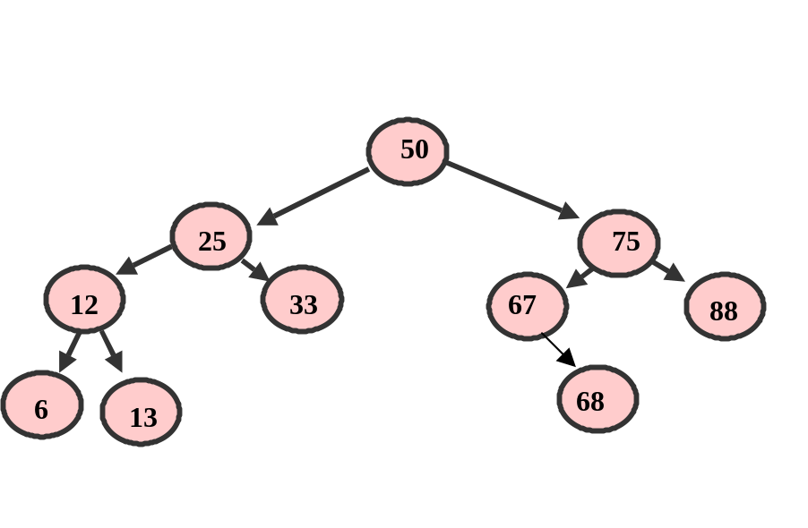

x

DELETE A LEAF NODE (#33):

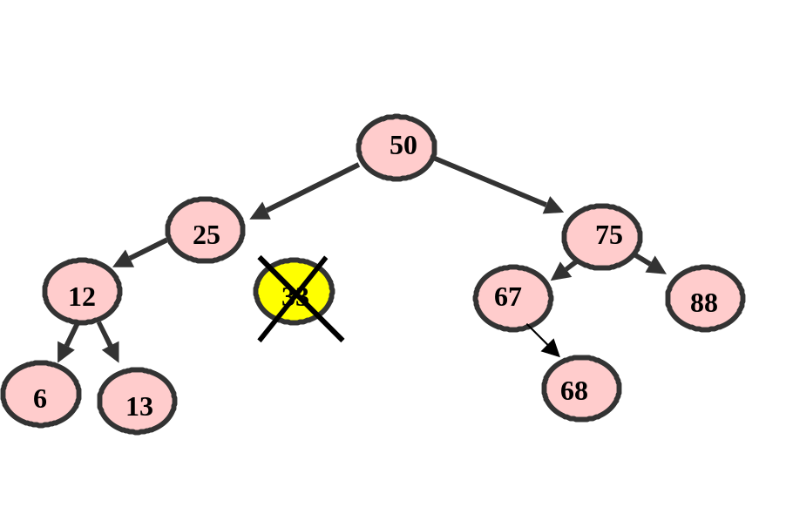

- Set the Parents, node 25, right node to null

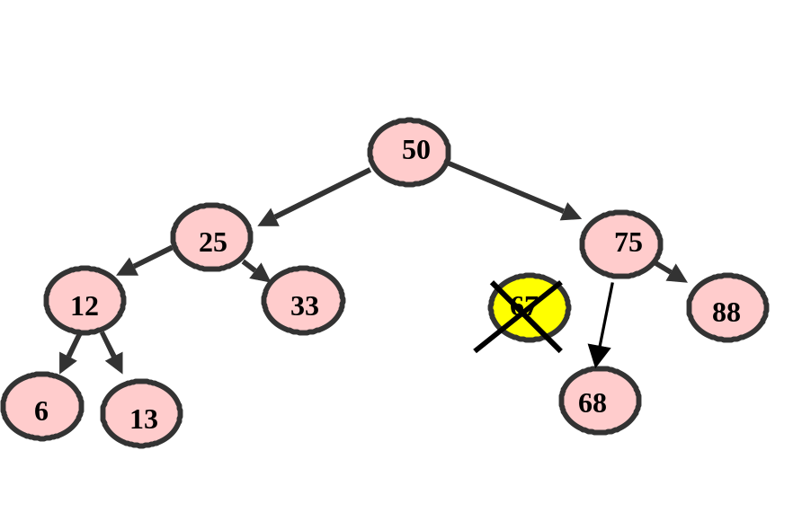DELETING A NODE THAT HAS ONE CHILD (#67):

- Rearrange the references to bypass the node by appending its only child directly to the removed node’s parent
- Have parents, #75, left child skip the deleted node and point to the child of the node being deleted

DELETING A NODE THAT HAS TWO CHILDREN (#50):

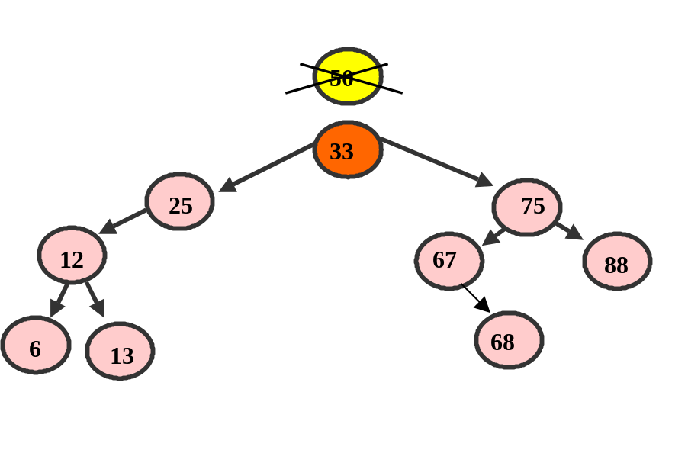
Go Left once
- Then go as far Right as possible for the node’s replacement (#33)
- Make THAT node the parent (to replace the deleted node)

